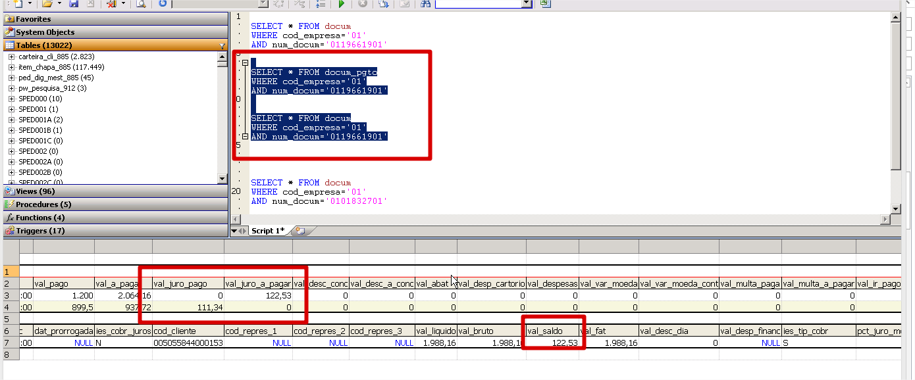

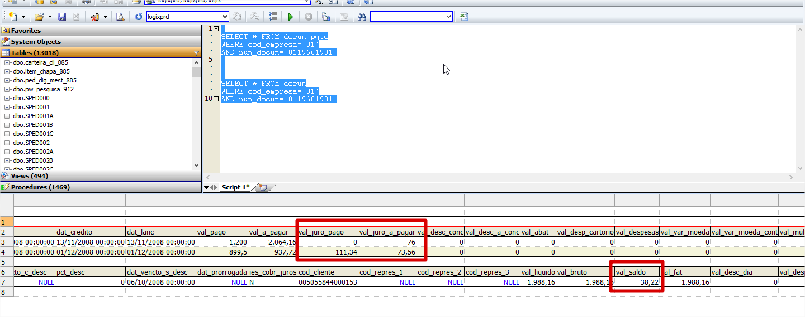

1º. pagamento

M_saldo = val_liquido = 1.988,16

l_dias_atraso = mr_docum.dat_pgto - mr_docum.dat_vencto = 38

l_tx_diaria = (m_pct_juro / 100 + 1) ** (1/qtd_dias_mes)

l_tx_diaria = (5 / 100 + 1) ** (1/31)= 1,0015751

l_tx_ressarcir = (l_tx_diaria ** l_dias_atraso) - 1

l_tx_ressarcir = (1,0015751 ** 38) - 1 = 0,0616312

m_val_juros = m_saldo * l_tx_ressarcir = 1.988,16*0,0616312=122,53

m_val_a_pagar = m_saldo + m_val_juros=1.988,16+122,53=2110,69

m_saldo = m_val_a_pagar – m_val_pago=2110,69-1200=910,69

2º. Pagamento

l_tx_diaria = (5 / 100 + 1) ** (1/31)= 1,0015751

l_tx_ressarcir = (1,0015751 ** 56) - 1 = 0,092137

m_val_juros = m_saldo * l_tx_ressarcir = 910,69 * 0,092137 = 83,91

m_val_a_pagar = m_saldo + m_val_juros=910,69 +83,91=994,60

m_saldo = m_val_a_pagar – m_val_pago = 994,60 – 899,50 = 95,10